Year 6 Maths facts to memorise
Time maths facts
- 60 seconds in a minute
- 60 minutes in a hour
- 24 hours in a day
- 7 days in a week
- 52 weeks in a year
- 4 weeks in a month
- 365 days in a year
- A leap year happens every 4 years: February has 29 days on a leap year
30 days hath September,
April, June and November, All the rest have 31, Excepting February alone.
Which only has but 28 days clear, And 29 in each leap year.
24 hour clock time to 12 hour am/pm time and vice versa :
1 am = 01:00  2am = 02:00  3am = 03:00  4am = 04:00  5am = 05:00  6am = 06:00  7am = 07:00  8am = 08:00 | 1pm = 13:00  2pm = 14:00  3pm = 15:00  4pm = 16:00  5pm = 17: 00  6pm = 18:00  7pm = 19:00  8pm = 20:00

9am = 09:00  10am = 10:00  11am = 11:00  12 noon/midday = 12:00 |  | 9pm = 21:00  10pm = 22:00  11pm = 23:00  12 midnight = 00:00
Example questions:
How many days are there in a leap year?
How many weeks are there in 3 months?
How many days in 3 weeks?
How many days are there in June and July combined?
What is quarter past 6 in the evening in 24hr clock time?
What is 21:19 in 12 hr am/pm time?
- The angles in a triangle add-up to 180°  - The angles on a straight line add-up to 180°  - The angles round a point add-up to 360 °  - The angles in a quadrilateral add-up to 360°  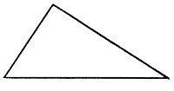  - A scalene triangle has 3 sides of different length and 3 angles of different size  - An isosceles triangle has 2 equal length sides and 2 equal size angles | - A  • | cute angle = 1-89°  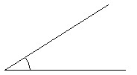  Right angle = 90°  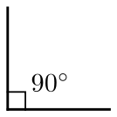  Obtuse angle = 91-179°  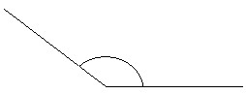
 | • | Straight line = 180°
 | • R | eflex angle = 181-359°

• | 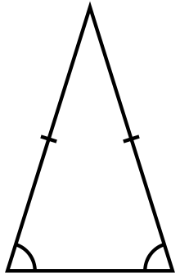  An equilateral triangle has all sides and angles equal: each angle in an equilateral triangle is 60°  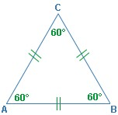 | • | 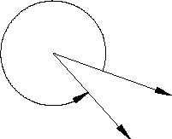  Complete turn = 360°
•  • | That to find the total interior of all the angles inside a regular polygon you need to follow the following formula: n (number of sides) – 2 x 180°  Memorising the table below will help with this: | •  • | That a circle contains a radius, circumference and a diameter: The radius is the length from the circumference of a circle to its centre.
 |  | • | The circumference is the length of the edge of a circle.
 |  | • | The diameter is a straight line going through the centre of a circle connecting two points on the circumference.
 | 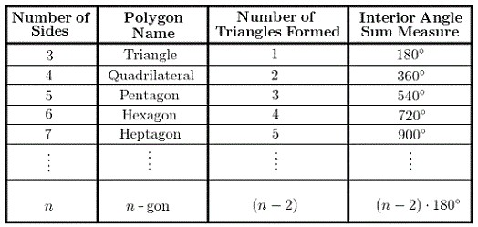 | • | The diameter can be found by multiplying the radius by 2 (d = r x 2).

 |  | 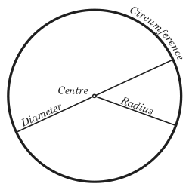
You need to recognise percentage, fraction and decimal equivalents.  50% = ½ = 0.5  10% = 1/10 = 0.1  30% = 3/10= 0.3  70% = 7/10 = 0.7  80% = 4/5 = 0.8  90% = 9/10 = 0.9  20% = 1/5 = 0.2  40% = 2/5= 0.4  60% = 3/5= 0.6  25% = 1/4 = 0.25  75% = ¾ = 0.75  1% =1/100 = 0.01  3% =3/100 = 0.03  7% =7/100 = 0.07 | A prime numbers has exactly 1 factor pair. The pair is always 1 and the number itself. 1 is not a prime number, as it only has one  factor: 1 x 1 = 1  2 is the only even prime number.  You should be able to list the first 10 prime numbers: 2, 3, 5, 7, 11, 13, 17, 19, 23, 29 |  | A square number is a number multiplied by itself. These are the first 10 square numbers: memorise them.  1² = 1 x 1= 1  2² = 2 x 2 = 4  3² = 3 x 3 = 9  4² = 4 x 4 =16  5² = 5 x 5 = 25 6² = 6 x 6 = 36  7² = 7 x 7 = 49  8² = 8 x 8 = 64  9² = 9 x 9 = 81  10² = 10 x 10 =100
A cubed number is a number multiplied by itself twice, for example: 3³= 3 x 3 x 3 These are the first 10 cubed numbers: memorise them.  1³ = 1 x 1 x 1 = 1  2³ = 2 x 2 x 2 = 8  3³ = 3 x 3 x 3 = 27  4³ = 4 x 4 x 4 = 64  5³ = 5 x 5 x 5 = 125  6³ = 6 x 6 x 6 = 216  7³ = 7 x 7 x 7 = 343  8³ = 8 x 8 x 8 = 512  9³ = 9 x 9 x 9 = 729  10³ = 10 x 10 x 10 = 1000 | In year 6, children are expected to convert between commonly used imperial and metric measurements. Therefore, it would be very useful if they knew the following conversion values:  - 1 km = ⁵/₈ mile  - 1 m = 39.37 inches  - 1 foot = 30.5 cm  - 1 inch = 2.54 cm  - 1 kg = 2.2 lb  - 1 gallon = 4.5 litres  - 1 litre = 1. 75 pints |  | Children are expected to be able to find the mean of a set of numbers. This is an average found by adding all the numbers together and then dividing your total by the amount of numbers there were, for example:  1 + 5 + 6 = 12  12 ÷ 3 = 4  So the mean is 4

You need to know how to convert between metric units:  10mg = 1cg  1000mg = 1g  100cg = 1g  100000cg = 1kg  1000g = 1kg  1000kg = 1 tonne  10mm = 1cm  1000mm = 1m  100cm = 1m  100000cm = 1km  1000m = 1km  10ml = 1cl  1000ml = 1l  100cl = 1l  100000cl = 1kl  1000l = 1kl  ½ a litre is 500ml  ¾ of a litre is 750 ml  1 of a litre is 250 ml  4  ½ a kilometre 500m  ¾ of a kilometre 750m  1 of a kilometre 250m  4  ½ a kilogram 500g  ¾ of kilogram 750g  1 of kilogram 250g  4  ½ a metre 50cm  ¾ of a metre 75cm  1 of a metre 25cm  4 | 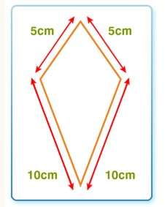  Perimeter  - The perimeter is the distance all the way around the outside of a 2D shape.  - To work out the perimeter, add up the lengths of all the sides.  The perimeter of this shape is 5 + 5 + 10 + 10 =  30 cm  Area  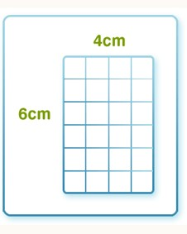  - The area of a 2D shape is the amount of surface it covers.  - To work out the area of a rectangle, multiply its length (the longer side) by its width (the shorter side):  area = length × width  The area of this rectangle is 6 x 4 = 24 cm²  Volume  The volume of a cube or cuboid = length x breadth x height
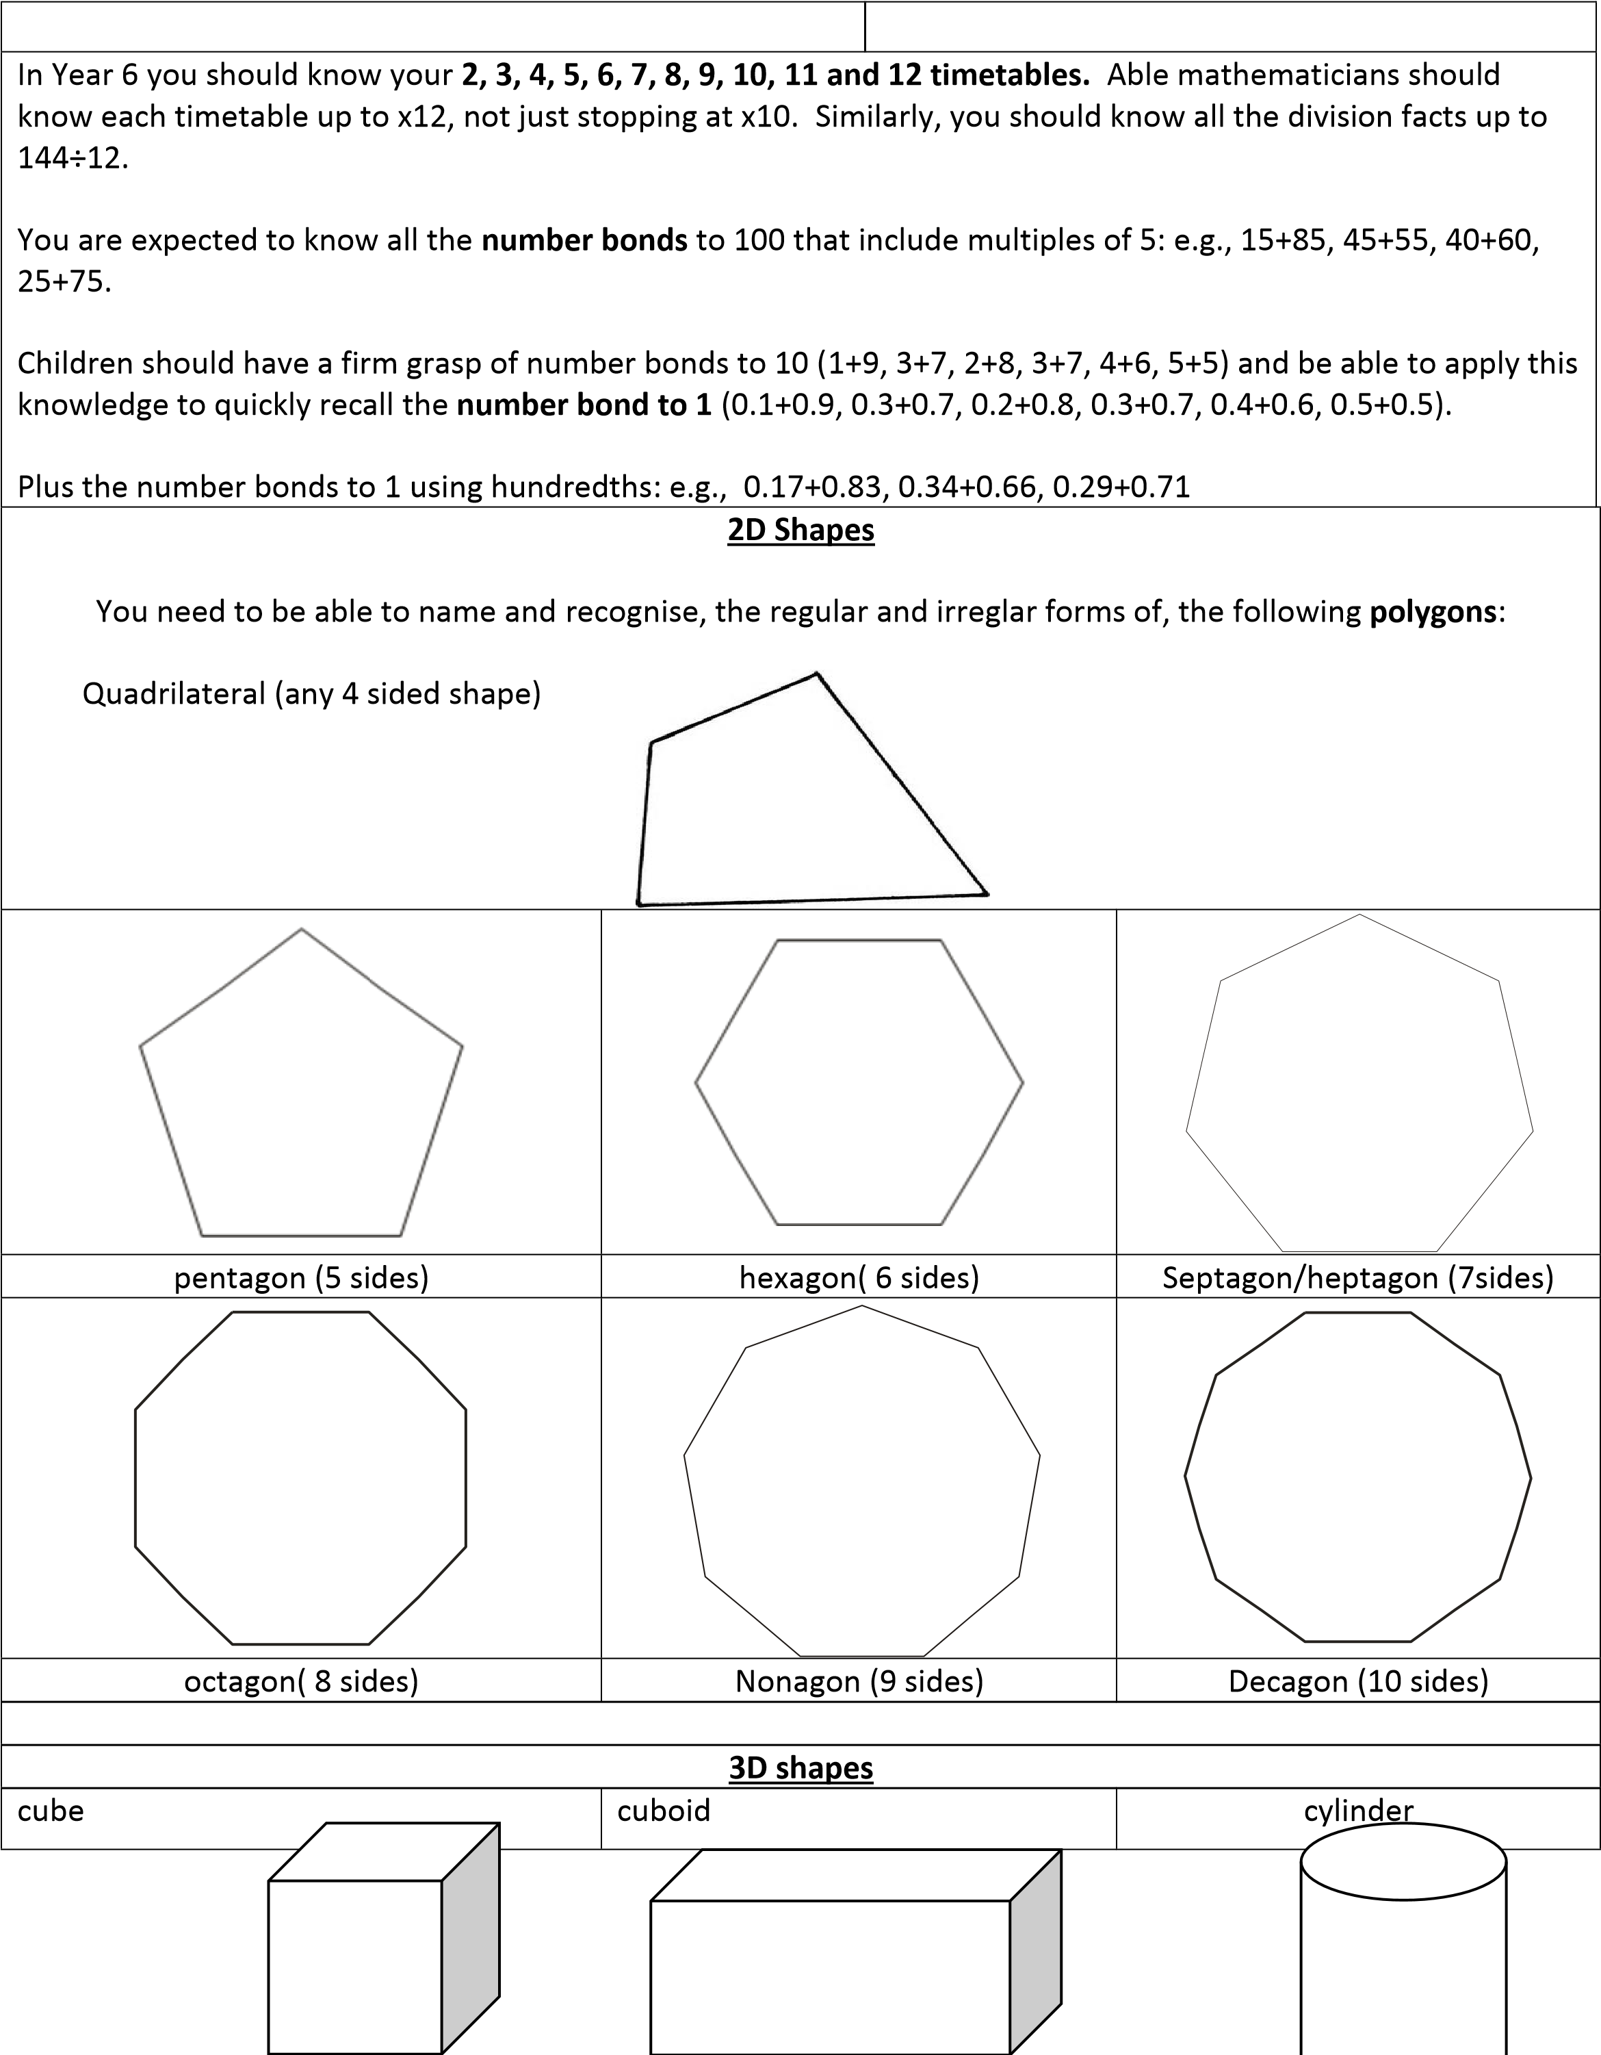

Triangular based pyramid (a tetrahedron is a triangular based pyramid where all the face are the same size.) | Square based pyramid | Pentagonal based pyramid
Triangular prism | Hexagonal prism | cone
Sphere | Hemisphere | Octahedron (a regular octahedron has eight equilateral triangles faces)

Sphere | 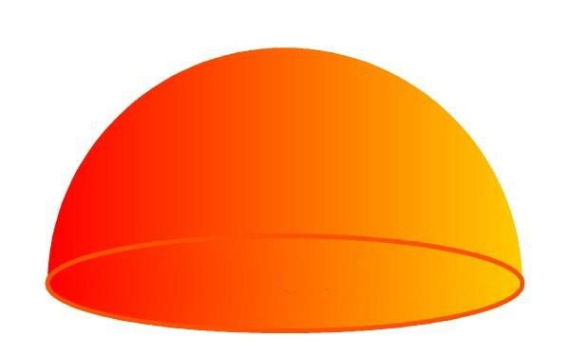  Semi-sphere |  | 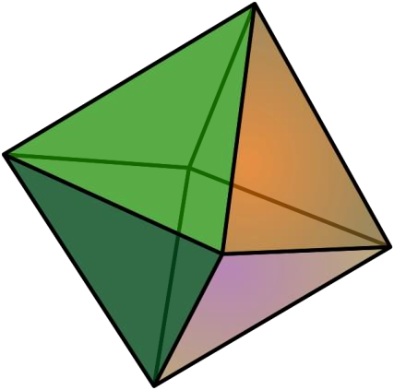  Octahedron
 | Roman Nu | merals
Arabic Numeral |  | Roman Numeral
1  2  3  4  5  6  7  8  9  10  20  30  40  50 |  | I  II  III  IV  V  VI  VII  VIII  IX  X  XX  XXX  XL  L
60  70  80  90  100  500  1000 |  | LX  LXX  LXXX  XC  C  D  M

Children should know the difference between parallel, perpendicular and intersecting lines.
- Lines are parallel if they are always the same distance apart (called "equidistant"), and will never meet. (They also point in the same direction).
- Perpendicular lines are lines that intersect each other at exactly a ninety degree angle. Lines are not perpendicular if the angles in which they intersect at are not equal to ninety degrees.
- Intersecting lines are where two lines meet or cross one another.
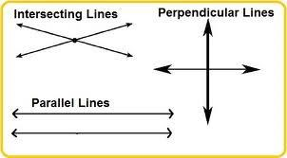
Children should memorise simple conversions between percentages and degrees in a pie chart. It would be very useful if they knew the following conversions:
10% = 36°
25% = 90°
50% = 180°
75% = 270°
33% = 120° (roughly)
66% = 240° (roughly)
20% = 72°

Fraction addition and subtraction. Children in year 6 are expected to know, off by heart, the following fraction addition and subtraction facts:
½ + ¼ = ¾
¾ - ½ = ¼
1/5 + 2/10 = 2/5
1/3 + 2/6 = 2/3
¼ + 2/8 = ½

¾ - ½ = ¼
¾ - 2/8 = ½
2/5 – 2/10 = 1/5
2/3 – 2/6 = 1/3
½ - 2/8 = ¼
Children will also be expected to know how to find the area of triangles and parallelograms.
Triangles:
The area is half of the base times height.
- "b" is the distance along the base
- "h" is the height (measured at right angles to the base)
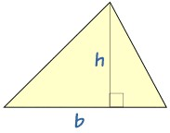
This formula works for all triangles (scaline, isoceles and equilateral); however, there is another way to find the area of a scaline triangle, but you do not need to know this in year 6.

Parallelograms:
The area is the base times height.
- "b" is the distance along the base
- "h" is the height (measured at right angles to the base)

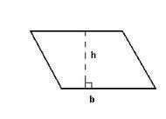

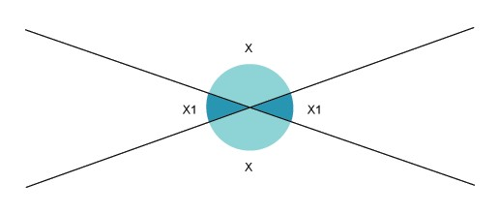
It would also be useful for children to know t
he following facts about angles on lines:

1.

When two lines intersect, the opposite (X) angles are equal:

2.

On parallel lines, alternate (Z) angles are equal:

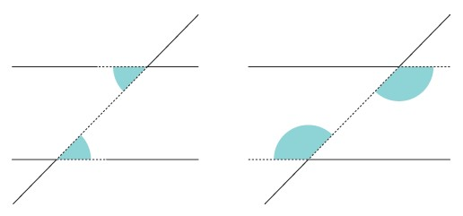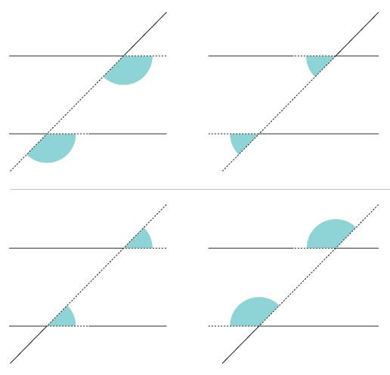

3.

On parallel lines, corresponding (F) angles are equal:

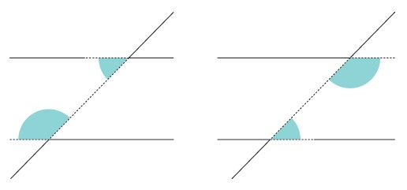
4.

On parallel lines, co
-
interior (C) angle
s add up to 180°:

