**Computing** - Unit 1.6 – Animated Stories –

Drawing and Creating

Animation

Sounds and More!

Making a Story

Copy and Paste –

**Art**

Weaving

To learn how to weave using two different coloured paper strips.

To learn how to weave using cloth.

To use different resources to create and design a card.

**English**

A daily phonics lesson, which supports reading and writing skills.

To develop fiction writing by using the story Man on the Moon

To develop non-fiction writing about Neil Armstrong and Tim Peake

Regular reading lessons.

**History**

To find out about Neil Armstrong and the first moon landing.

To know that the space programme which continues and who Tim Peake is.

**Maths**

To develop mathematical knowledge in

Multiplication

Division

Fractions

Geometry – Length

Position & Direction

2D & 3D Shapes

Statistic – Data Handling

**Spring 2 – To infinity and beyond**

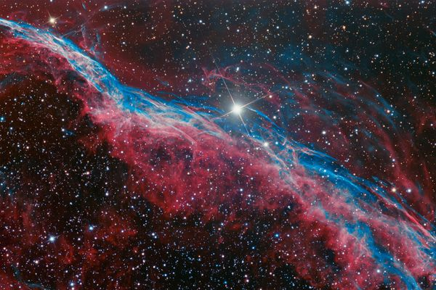

Figure To infinity and beyond

**PSHE** – **What helps as stay healthy?**

How rules and restrictions help them to keep safe (e.g. basic road, fire, cycle, water safety; in relation to medicines/ household products and online).

How to identify risky and potentially unsafe situations (in familiar and unfamiliar environments, including online) and take steps to avoid or remove themselves from them.

How to resist pressure to do something that makes them feel unsafe or uncomfortable, including keeping secrets.

**Science** –

Animal Offspring

Life Cycles

Growing Up

Survival

Exercise

To experience space food.

**Geography**

To locate Wales in the United Kingdom.

To learn about St David’s Day and some facts about Wales.

To locate Northern Ireland in the United Kingdom.

To learn about St Patrick’s Day and some facts about Ireland.

**RE –**

Why is giving important to Christians?

Giving – What? When? Why?

How might we ‘give’ to others this week?

What is ‘worship’?

How do Christians (the church) give to God in worship?

**PE**

To learn Football Skills

To practise Multi-Skills

**Music**

Charanga – Recognising different sounds.