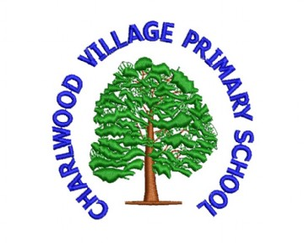
Charlwood Village Primary School PTA

Purpose
CVPS PTA is soon to be a registered charity which aims to provide support and funding for the educational enhancement of the children who attend the school.
What we do
We run a series of events and activities throughout the year for the children, parents and community to raise vital funds for the school. These can be as simple as cake sales, second hand uniform sales and ice cream Thursdays or larger organised events such as kids film fun, xmas craft and auction of promises.
What we fund
Our aim is to enhance the learning environment for the children of the school and some of the key areas we have funded this school term include:
- Investment and upkeep of the guinea pigs
- Reading books
- Subsidise the school mini bus
- Subsidise class educational trips and swimming
How much do we raise?
To date in the 2018/2019 school term we have raised a brilliant
£5391 with £14,399 in the bank
How can you help?
We are a small, inclusive but growing school and like any other school funding is decreasing. To help the school deliver on their commitment to develop and nurture children who are Confident, Valued , Prepared and Successful we need to fundraise more and more money to enhance their learning experiences.
So as a starter for five you can HELP us by:
- Joining the PTA to help us deliver on our purpose
- Partake in some of the fundraising activities/events (as many or as few as you want!)
- Come up with new ideas to help us raise vital funds
- Donate your time and energy to running an event or activity
- Attend future PTA meetings

Who’s who?
Chair – Jayde Betchley (Year 4 parent)
Secretary – Tracey Fielden (Year 5 parent)
Treasurer – Becky King (Year 4 and 5 parent)
School Uniform – Iley Harris (Year 5 parent)
Given this core group has been involved for a number of years and their children are leaving after Year 6 we REALLY NEED NEW COMMITTEE MEMBERS URGENTLY. From September 2019 we need a new Chair and a new secretary. The roles are not daunting as we are all parents working towards the same goals for our children.

When do we meet and how do we communicate?
We try to meet as a PTA committee once per month on a Monday or Tuesday evening from 7pm at the school. Everyone is welcome and we discuss fundraising activities and school funding requests. For those who cannot or do not want to attend we send updates and requests via the Charlwood Parents Group: “What’s App” group. We also may send communication out via the School Parent’s Mail system or as hard copies in children’s book bags, As an eco school we prefer electronic communication where feasible.
Contact Us
We would love to hear from you so if you have a question then please do not hesitate to reach out and ask us.
For ease please contact in the first instance the PTA secretary tracey@churchview.eu
INFORM ME…..

To ensure that you are kept abreast of any Charlwood Village Primary School PTA Events/Activities/ Meetings or need to ask any parent a question – we will add you to the Charlwood Parents Group on What’s App. As such you can leave at any time if you feel the content and updates are unsuitable!
To opt in to this group please provide your name and contact details below

Name:

Child’s Name:

Child’s Class:

Your mobile number:

Please refer to our privacy statement to understand how your data will be used. Copies are available on request.

